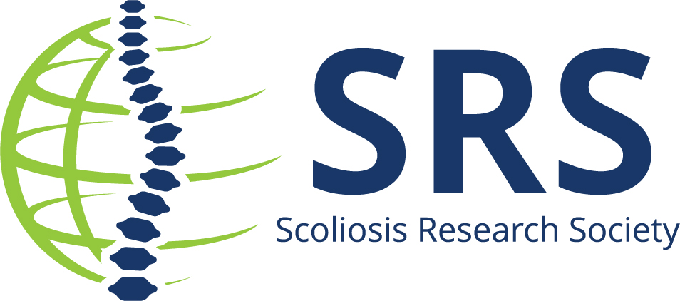
Contact: Name/Email/Phone for follow up

(Insert name) to Present at the Current Concepts in Spine Deformity Course in Prague, Czechia

(insert city, state) – (insert name of institution) is pleased to announce that (insert name) is one of the presenters at the prestigious Current Concepts in Spine Deformity Course.
This curriculum-based course hosts regional residents, fellows, orthopaedic and neurosurgeons who have an interest and are involved in spinal deformity management and treatment. Dr./Professor/ (Insert name) is presenting on the (insert topic) on date/ day/time.
(insert quote or more details on topic)
For more information review the preliminary program.
This educational, interactive regional course is designed by the Scoliosis Research Society and features the instruction of highly regarded members, including the current SRS President. The course combines lectures, case presentations, and panel discussions covering a broad range of spinal deformity issues.
Presenting among the international audience of spine professionals is a great honor.
About Scoliosis Research Society
The Scoliosis Research Society is a non-profit, professional organization, made up of physicians and allied health personnel. Our primary focus is on providing continuing medical education for health care professionals and on funding/supporting research in spinal deformities. Founded in 1966, SRS has gained recognition as the world's premier spine deformity society. Please visit www.srs.org for further information. Also follow us on Twitter, Facebook, LinkedIn and Instagram.
###

