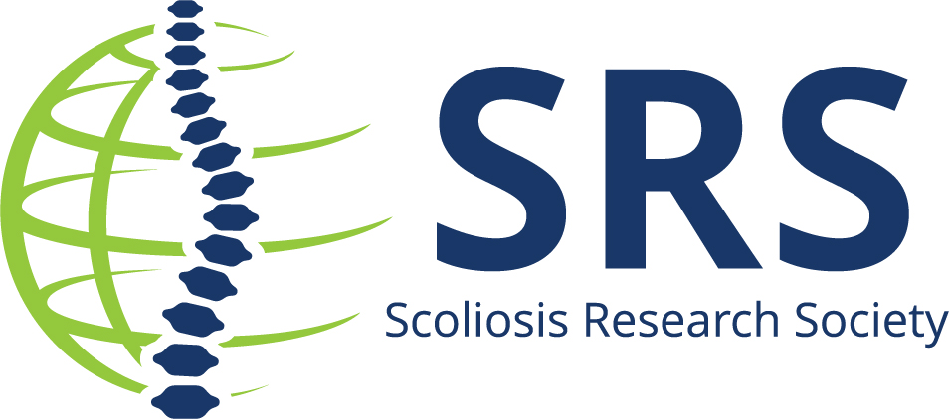

Contact: Michele Sewart, PMP | Scoliosis Research Society
msewart@srs.org |414-231-8158

Name of Institution/Hospital is Pleased to Announces Insert Name is the Winner of the Prestigious Russell A. Hibbs or John H. Moe or Louis A. Goldstein Awards
During the 58^{h} Annual Meeting Seattle, WA, the Scoliosis Research Society (SRS) announced the winners of the Russell A. Hibbs, John H. Moe & Louis A. Goldstein Awards. Named after pioneers in scoliosis surgery, the awards are given to the best basic research and best clinical research papers.

Choose the winning paper information:

Hibbs Best Clinical: Paper 78- The Reunion with my Patients. Their Journey and Experience 30 Years after Their Intervention for Adolescent Idiopathic Scoliosis (AIS) via CD Instrumentation, Javier Pizones (Ferran Pellise will be accepting in person)
Hibbs Best Basic Science: Paper 83- Hierarchical Evaluation of Mechanically Induced Growth Modulation of the Spine in a Growing Pig Model, Patrick Cahill
John H. Moe Best Basic Science E-Point: Paper 227- Soft-tissue Insufficiency as a Predictor for Proximal Junctional Kyphosis and Failure in Patients with Adult Spinal Deformity, Bahar Shahidi
Luis A. Goldstein Best Clinical Research E-Point: Paper 220- Influence of smoking on patient-reported outcome measures (PROMs) in patients undergoing surgery for adult spinal deformity. A propensity score‐matched analysis excluding known tobacco-related complications, Alejandro Gomez-Rice

Nominees for the awards are selected by the Program Committee from the submitted abstracts for SRS Annual Meeting. The nominees are invited to submit their paper’s manuscript which is reviewed by the Program Committee. During the meeting, attendees vote for their favorite presentation via the SRS Annual Meeting app and the popular votes and manuscript scores are taken into consideration by the Program Committee, who select the final winners.

Insert quote

About Scoliosis Research Society
The Scoliosis Research Society is a non-profit, professional organization, made up of physicians and allied health personnel. Our primary focus is on providing continuing medical education for health care professionals and on funding/supporting research in spinal deformities. Founded in 1966, SRS has gained recognition as the world's premier spine deformity society. Please visit www.srs.org for further information. Also follow us on Twitter, Facebook, LinkedIn and Instagram.
###

